**EsemkaCorporation Test Project**

**Introduction**

**EsemkaCorporation** is a corporation providing Information Technology Services. It has **five** **departments** (**Information Technology, Operations, Finance and Accounting, Procurement, Human Capital**) leads by **Board of Management**. The **job** position is ordered in **ascending** from **Staff, Officer, Supervisor, Manager, to Director**.

They would like to develop a new **Desktop** **Application** using **C# Programming Language** to manage their **employee** **data**. The application must have several features such as **login** **authentication**, **viewing** **employee** **profile**, or **applying** **for** **job** **mutation** or **promotion**. Below are some of the requirements that has been arranged by the analysts and designers.

**Contents**

In this test project there are some files and usable resources:

1. EsemkaCorporation_TP.pdf (Test project file)
2. EsemkaCorporation_DB.sql (Database Script File)

**Project Description and Tasks**

* Project Criteria:
  + The project name should be “DESKTOP_I_[XX]”, where XX is your PC number.
  + Time management is a crucial factor for the success of this project. So, manage your time wisely and submit all your works on time.
* Application User Interface:
  + The application wireframe is already provided. You are allowed to modify the application interfaces as long as it doesn’t interfere the business and application flow.
  + The scoring will be focused on the features of the application.
* Validation and Error Messages:
  + The application must runs well with a proper validation and shows a useful error messages to the user.
  + Analyze the required validation(s) that is/are needed in the application. This is one of the scoring criteria for your analytical skills for the project. Any specific validation will be given in the project description.

**Entity Relationship Diagram**

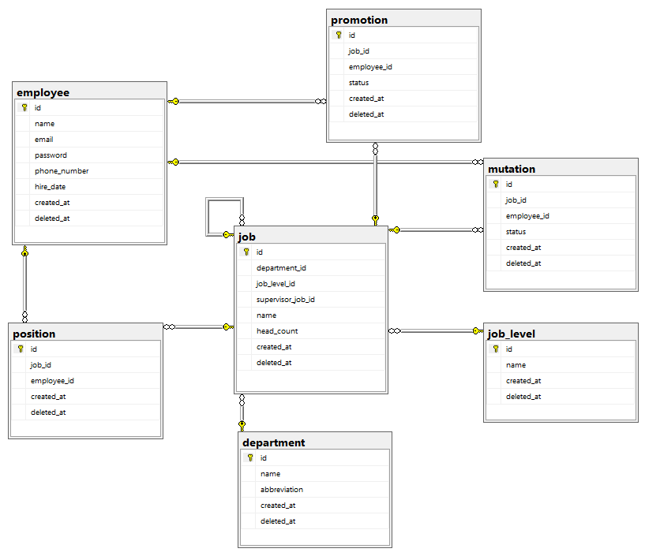

Entity-Relationship Diagram (ERD) is provided to help you understand the database structure of the requested EsemkaCorporation Desktop Application. This diagram explains the concept and representation of the data model that is used in the database.

NB: The database implements **soft** **delete** technique; it means that records are not actually removed from the database. Instead, a **‘deleted_at’** timestamp is set on the record.

1. **Login Form**

This is the first screen that will be used by the employee to login to the application. Employee can **login** to the application by **filling** **their** **email** and **password**.

* + If the **combination exists** in the database, the user will be **directed** **to** the **main screen** of the application.
  + If the **combination doesn’t exist** in the database, **let the user know**.

1. **Main Form**

In this screen, employee can navigate to other forms.

* Display the **employee's** **name**.
* **Button** **Profile** redirects employee to **Profile** **Form**.
* **Button Apply for Job Mutation** redirects employee to **Mutation** **Form**.
* **Button** **Apply** **for** **Job** **Promotion** redirects employee to **Promotion** **Form**.
* **Button Logout** ends current employee session and redirects to **Login** **Form**.

1. **Profile Form**

**Profile** **Form** shows the previously selected employee profile.

* Thisform **shows** the employee **profile** **detail**. All data shown is **non editable**.
* Clicking the **Direct** **Supervisor** **Link** **Text** will redirect to the **profile** **form** of that **supervisor**.
* **Job** **History** **DataGridView** displays all the employee's previous job positions ordered by job level descending.
* **Subordinate DataGridView** display all the employee's direct subordinate.
* **Works** **With** **DataGridView** displays all other employee that share same supervisor with this employee.
* **Button Main** can be used to **redirect to Main Form.**

1. **Mutation Form**

**Mutation** **Form** is used by the employee to apply for **job** **mutation**.

* This form shows the employee **job** **detail**. All data shown is **non** **editable**.
* **Available** **Job** **Mutation** **DataGridView** displays all **applicable** **job** **positions** for the employee to apply. The requirements are:
* Must be in the **same job level** as **current** **job** **position**.
* There is **vacancy** for those job position.
* **Cross department** job position is **allowed**.
* The employee can apply to the job position by clicking **Apply** **Button** in the selected row. Once the application is made, **disable** the **Apply** **Button**. The **application status then will be set as ‘Pending’.**
* **Multiple** **application** at the same time is **allowed** if it is **different job position**.
* **Button** **Main** can be used to redirect to **Main** **Form**.

1. **Promotion Form**

**Promotion** **Form** is used by the employee to apply for **job** **promotion**.

* This form shows the employee **job** **detail**. All data shown is **non** **editable**.
* **Available** **Job** **Promotion** **DataGridView** displays all **applicable** **job** **positions** for the employee to apply. The requirements are:
* Must be **one** **level** **above** the **current** **job** **position level**.
* There is **vacancy** for those job position.
* **Cross department** job position is **allowed**.
* The employee can apply to the job position by clicking **Apply** **Button** in the selected row. Once the application is made, **disable** the **Apply** **Button**. The **application status then will be set as ‘Pending’.**
* **Multiple** **application** at the same time is **allowed** if it is **different job position**.
* **Button** **Main** can be used to redirect to **Main** **Form**.

**“Talk is cheap. Show me the code.” - Linus Torvald**